Western CTSO’s

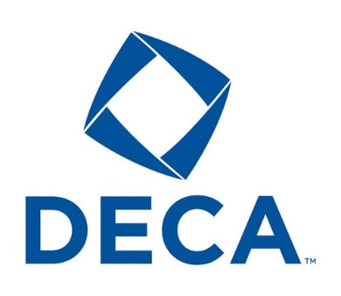

DECA prepares emerging leaders and entrepreneurs in marketing, finance, hospitality and management in high schools and colleges around the globe.

Advisor: Mr. Brian Wise [wiseb@gcsnc.com](mailto:wiseb@gcsnc.com)

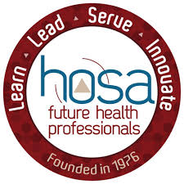

The mission of HOSA is to empower HOSA- Future Health Professionals to become leaders in the global health community through education, collaboration and experience.

Advisor: Ms. Amber Shelar [shelara@gcsnc.com](mailto:shelara@gcsnc.com)

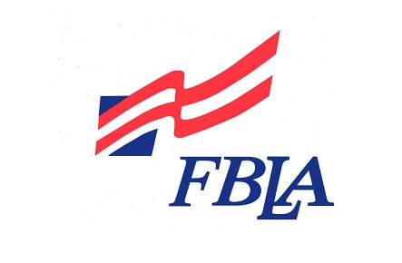

Future Business Leaders of America (FBLA) is the premier student business organization. Our mission is to bring businesses and education together in a positive working relationship through innovative leadership and career development programs.

Advisor: Ms. Amma Waddell [waddela@gcsnc.com](mailto:waddela@gcsnc.com)

Skills USE empowers its members to become world-class workers, leaders and responsible American citizens. We improve the quality of our nation’s future skilled workforce through the development of SkillsUSA Framework that include personal, workplace and technical skills grounded in academics.

Advisors: Mr. Jeffery Silverthorne [silverj2@gcsnc.com](mailto:silverj2@gcsnc.com)

Ms. Nicole Penn [pennn@gcsnc.com](mailto:pennn@gcsnc.com)

